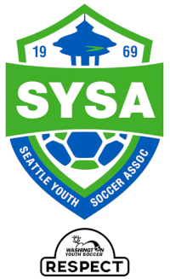

2021 SPRING SOCCER GAME LOCATIONS

AGE GROUP | LOCATION #1 | LOCATION #2 | LOCATION #3 | LOCATION #4 | LOCATION #5 | LOCATION #6
U6/7 | Lower Woodland #2
U8 | Garfield HS
U9 | East Queen Anne | BF Day Elem. | Ridgecrest Elem. | Van Asselt
U10 | BF Day Elem. | Salmon Bay | McGilvra Elem. | Ridgecrest Elem. | Van Asselt
U11+ | Whitman MS | Eckstein MS | Interbay | Shoreline A/B | Franklin HS | Rainier Beach HS

